The ChocAn Simulator
Requirements Document
Group 1:
Rudd Johnson
Justin Moore
Daniel Eynis
Rohan Elukurthy
Timothy Handojo
Table of Contents
1 Introduction 3
1.1 Purpose and Scope 3
1.2 Target Audience 3
1.3 Terms and Definitions 3
2 Product Overview 4
2.1 Users and Stakeholders 4
2.1.1 Patients 4
2.1.2 Health Care Professionals 5
2.2.3 Chocoholics Anonymous.............................................................................5
2.2.4 IT Professionals...........................................................................................5
2.2 Use cases 6
2.2.1 Determine Member Validity 6
2.2.2 Member Billing 6
2.2.3 Provide Request of Services from The Provider Directory 7
2.2.4 Main Accounting Procedure........................................................................7
2.2.5 ChocAn Manager Viewing Weekly ServicesReport...................................8
2.2.6 EFT Records................................................................................................8
2.2.7 Weekly Manager Summery Report.............................................................8
2.2.8 Daytime Software Interactive Mode...........................................................8
2.2.9 Use Case Sequence Diagram..............................................................................9
3 Functional Requirements 10
3.1 The system shall verify the a member using the members 9 digit number 10
3.2 The system shall be able to bill ChocAn after a health care service has been provided to the member 10
3.3 The provider shall be able to request a copy of the Provider Directory...........11
3.4 The system shall keep records of each member who has consulted a ChocAn provider during a week and keep a sorted list of services provided to each member...11
3.5 The system shall compile a report for each provider who has billed ChocAn during a particular week containing the list of services they provided to ChocAn members 12
3.6 The system shall create a record of the electronic funds transfer (EFT) data…13
3.7 The system shall be able to run in an interactive mode to allow operators to manage the patient and provider data……………………………………………………13
4 Nonfunctional Requirements 14
4.1 Product Requirements 15
4.2 Organizational requirements 16
4.3 External requirements 17
5 Milestones and Deliverables 18
5.1 Design Document...............................................................................................18
5.2 Member Authorization 18
5.3 Member Billing………………………………………………………………..18
5.4 Provider Directory request…………………………………………………….19
5.5 Main Accounting Procedure…………………………………………………..19
5.6 ETF Record…………………………………………………………………....19
5.7 Manager Summery…………………………………………………………….19
5.8 Interactive Mode………………………………………………………………20
5.9 Test Plan………………………………………………………………………20
5.10 Project Report and Final Deliverables………………………………………...20
5.11 Gantt Chart
…………………………………………………………………….20

Introduction
This documents delineates requirements for data processing software commissioned by Chocoholics Anonymous (ChocAn) for the system developers of this software. ChocAn, a for profit health care entity that provides chocolate addiction treatment to its clients with the aim of freeing them from chocolate dependence and maintaining long term abstinence. The following document will contain a detailed product overview of information regarding functional requirements, nonfunctional requirements, and use cases for the software in addition to details about product users and stakeholders. Finally, this document will outline the phases of development and associated milestones and deliverables in thereof to ChocAn.

Purpose and Scope
The purpose of this document is to identify product stakeholders, product use cases and outline, in detail, the software requirements, product milestones and deliverables for the developers of ChocAn data processing software. Additionally, this document will specify the scope of this software and the service it provides for ChocAn, more specifically, its function exclusively as data processing software and its interface with third party software being developed for communication between the ChocAn provider's terminal with Acme Accounting Services and EFT between business entities

Target Audience
The target audience of the documents are the system developers for the data processing software to be rendered for ChocAn. This document will serve as an official reference for the requirements (both functional and nonfunctional) of the commissioned software as well as a guide for software milestones and deliverables by the system developers to ChocAn.

Terms and Definitions
EFT- Electronic Funds Transfer

Product Overview
The purpose and function of this project is to develop data processing software for Chocoholics Anonymous (ChocAn). This section will provide an overview of users, stakeholders, and use cases. The ChocAn data processing software shall be used by the employees of ChocAn to keep track of users and provider records. The stakeholders of this project and software are ChocAn, the members, and the health care professionals that work for ChocAn. The software will allow health care professionals such as dietitians, physicians, internists, and exercise specialists to bill members and to keep track of previous services provided. The software will allow the appending, editing, and deletion of any and all member and provider records from the ChocAn system. The organization has been contracted to only write the data processing software. The communications software will be developed by another organization. That organization will be responsible for the software needed by Acme Accounting Services, and for implementing the EFT component. The processing of payments has been contacted out to Acme Accounting Services.

Users and Stakeholders
The purpose of this section is to describe the users and stakeholders of this software. The stakeholders role in the development, deployment, use, and maintenance of the software will be examined here.

Patients
The patients will be stakeholders because all of their information will be recorded in the system. The software being developed is responsible for data processing so it is in the best interest to make it as reliable as possible for the patients. The patients will have no role in the development, deployment, or maintenance processes. However, the patients will play a big role in the indirect use of the software because their information will be managed by the data processing software.
2.1.2 Health Care Professionals
Health care professionals are also stakeholders. Health care professionals include dietitians, physicians, internists, and exercise specialists. These professionals will be responsible for treating patients, and managing patients information. The managing of patient information will come from the data processing software that is being developed by this organization.

2.1.3 Chocoholics Anonymous
Chocoholics Anonymous are stakeholders as they are the ones who have contracted this organization to design and develop the data processing software. ChocAn will be providing the financing for this project. The ChocAn data processing software will be crucial to the managing of patient and provider records that ChocAn relies on for their business. They are also financing the development, deployment, and maintenance of the software.
2.1.4 IT Professionals
The IT professionals are stakeholders and they will be heavily involved in the deployment and maintenance of the software. The IT professionals will be responsible to deploy and teach the health care professionals on how to operate the software. The IT professionals will also address any issues with the software. They must install and maintain the software throughout ChocAn.

Use cases
This section will identify the critical interactions between ChocAn members and providers with the data processing software and database and describe them at a high level. More detail will be gone into in the functional and non-functional requirements sections. Visual representation of the work flow between members, providers, and the data processing software is attached after this section.

Determine Member Validity
- Member hands card to provider whom swipes card in terminal.
- The Software parses the member database for the associated member code
  - If the member number is found and membership is valid, return “Validated” to provider.
  - If the member code is found and the membership payment is greater than 1 month delinquent and account is suspended, return “Member Suspended” to provider.
  - If member number is not found, return “Invalid Number” to provider.
- Provider informs Member of their membership status.

Member Billing
- After the member code is found, if the membership payment is greater than 1 month delinquent and account is suspended, return “Member Suspended” to provider.
  - If member number is not found, return “Invalid Number” to provider.
- The provider enters the date of the member service.
- Provider queries data processing software for six digit service code corresponding to service provided.
- Software queries Provider Directory database for appropriate six digit service code.
  - If code is found, appropriate code is returned to provider.
  - If code isn't found, error returned to provider.
- Provider verifies the service code returned is correct by querying the data processing software for the service name with the returned service code
- Software queries the Provider Directory database for the service corresponding with the code.
  - If the service is found, it's returned to the provider.
  - If the service isn't found, an error is returned.
- Software prompts provider with Y or N to verify the correct service.
  - If provider enters Y, they are given the option of writing comments about the service provided then the software saves information regarding the customer, provider, and service provided to disk.
  - If the provider enters no, the program terminates.
- Software queries Provider Directory for fee associated with provided service and returns value to the provider with a verification form containing information about the date and time the service was provided, member information, service code and fee. This information is used for the provider to verify their totaled fees at the end of each week.

2.2.3 Provide Request of Services from The Provider Directory
- The provider requests from complete alphabetized Provider Directory.
- The software e-mails an attachment to the provider containing the complete alphabetized Provider Directory.
2.2.4 Main Accounting Procedure
- At midnight each Friday, the ChocAn Data Center queries the data base for the week's file containing information about services provided.
  - Each member who has received services that week is sent an e-mail containing their name, address, and for each service provided: date of service (mm:dd:yyyy), provider name, and service name.
  - Each provider who has billed that week is emailed a report containing the providers name, address, total consultations, total weekly fees, and for each service: the service provide, data and time service was provided, member name, member number, service code, and fee for service.
- 2.2.5 ChocAn Manager Viewing Weekly Services Report
- A ChocAn manager individually requests from the software the file containing that week's services provided.
- The software queries the data base for and email and prints that weeks file containing services provided by specific providers, members receiving services, fees associated with services, and total fees for the week for the ChocAn manager.
- 2.2.6 EFT Records
- All EFT's are written to disk by data processing software for bank's records
- 2.2.7 Weekly Manager Summery Report
- Weekly summary report generated by Software containing providers to be paid, number of consultations each provider had, each providers total fees for the week, and the total number of providers who provided services.
- Report is e-mailed to the ChocAn manager.
- 2.2.8 Daytime Software Interactive Mode
- During the day, Software allows operators to add and remove members from the database.
- Software allows providers records to added, removed, or updated in the data base
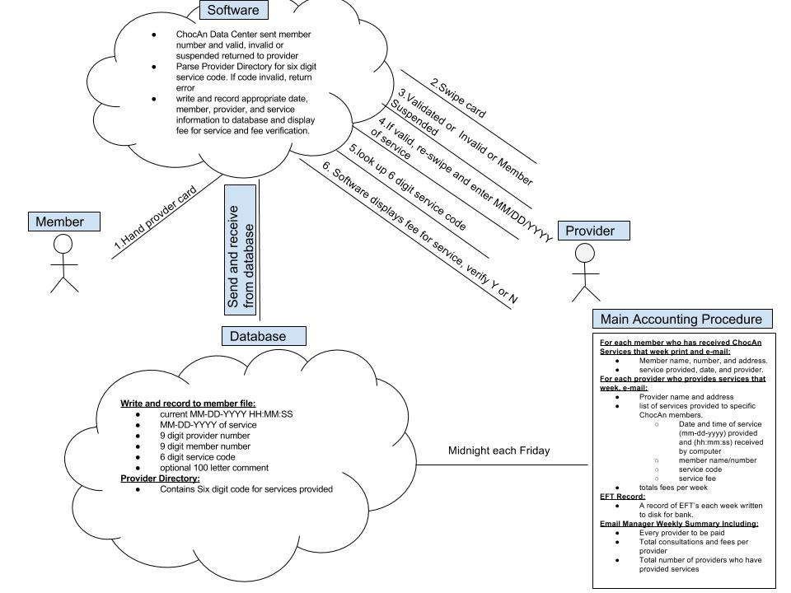
2.2.9 Use case sequence diagram

Functional Requirements

3.1 The system shall verify the a member using the members 9 digit number.
  - Each member at ChocAn shall be uniquely identified by a 9 digit number.
  - If the number is valid the word VALIDATED appears on the terminal. If the number is not valid the reason will be displayed such as INVALID NUMBER or MEMBER SUSPENDED. An invalid member number will send the user of the software back to the screen to enter the member number again. The system shall parse a file database to verify if a member is validated, has an invalid number, or is suspended.
  - The system shall be able to bill ChocAn after a health care service has been provided to the member.
  - When a member number is entered and the word VALIDTED appears, the provider will key in the date the service was provided in the format MM-DD-YYYY. The provider will then key in the 6 digit service code which they can look up from the Provider Directory.
  - The system then shall verify the service code that was entered by parsing the Provider Directory. If the service code is valid the system shall display the name of the service corresponding to the code (up to 20 characters). The system shall ask the provider to verify that the service number entered is valid by entering y or n into the terminal. If the provider has entered an invalid code, and error message shall be printed and the provider taken back to the screen to enter a service code again.
  - If the service code is validated, the provider can enter comments about the service provided, then the system shall write a record to disk that includes the following format and information:
    - Current date and time (MM-DD-YYYY HH:MM:SS).
    - Date service was provided (MM-DD-YYYY).
    - Provider number (9 digits).
    - Member number (9 digits).
    - Service code (6 digits).
    - Comments (100 characters) (optional).
  - The system then shall parse the Provider Directory to look up a fee to be paid for the service that was keyed in and displays it on the providers screen. The system shall also display a form with the current day and time, the date service was provided, member name and number, and service code. This is done for verification purposes. The provider will key in y or n to verify the information.
3.3 The provider shall be able to request a copy of the Provider Directory.
  - The system shall parse the Provider Directory and compile an alphabetically ordered list of service names and their corresponding service codes and fees. The system then shall email the provider the compiled list of services from the Provider Directory as an attachment.
3.4 The system shall keep records of each member who has consulted a ChocAn provider during a week and keep a sorted list of services provided to each member.
  - Each member report shall be written to its own file, and the file shall begin with the member name followed by the date of the report.
  - The patients shall receive a list of provided services for a particular week. The report shall include the following format and information:
    - Member name (25 characters).
    - Member number (9 digits).
    - Member street address (25 characters).
    - Member city (14 characters).
    - Member state (2 letters).
    - Member zip code (5 digits).
    - Each service will have the following information stored:
      - Date of service (MM-DD-YYYY).
      - Provider name (25 characters).
      - Service name (20 characters).
3.5 The system shall compile a report for each provider who has billed ChocAn during a particular week containing the list of services they provided to ChocAn members.
  - The report shall contain the information entered in the providers form in the order it was received by the system. The report shall also include the number of consultations a provider has with members and the total fee for a particular week.
  - The fields in the report must include the following format and information:
    - Provider name (25 characters).
    - Provider number (9 digits).
    - Provider street address (25 characters).
    - Provider city (14 characters).
    - Provider state (2 characters).
    - Provider zip code (5 digits).
    - Each service will have the following information stored:
      - Date of service (MM-DD-YYYY).
      - Date and time data was received by computer (MM-DD-YYYY).
      - Member name (25 characters).
      - Member number (9 digits).
      - Service code (6 digits).
      - Fee to be paid (up to $999.99).
    - Total number of consultations with members (3 digits).
    - Total fee for the week (up to $99,999.99).
3.6 The system shall create a record of the electronic funds transfer (EFT) data.
  - The system shall write the data to a file on disk.
3.7 The system shall be able to run in an interactive mode to allow operators to manage the patient and provider data.
  - The system shall allow operators to add, delete, and update member records of ChocAn. Provider records shall also be able to be added, deleted, or edited.

4 Nonfunctional Requirements
The purpose of this section is to outline nonfunctional requirements for the ChocAn data processing software. These nonfunctional requirements will define system properties, reliability, response time, and storage requirements. Constraints may include I/O device capabilities. Process requirements will also mandate a particular IDE or programming language. Nonfunctional requirements will include product, organizational, and external requirements.

Product Requirements
- Product requirements shall specify that the product must behave in a particular way in regards to execution speed and reliability.
- The ChocAn data processing software shall be available to all operators at ChocAn that need to use the data processing software. The data processing software will also be available during normal working hours at ChocAn facilities. Downtime of the system shall not exceed four seconds within normal working hours.
  - The retrieval of patient or provider records shall not exceed more than ten seconds. The retrieval of data is dependent on the size of the file database and therefore retrieval times may vary.
  - The writing of patient and provider information to the file database shall not exceed two seconds in time.
  - The data processing software shall be written in the Java programming language.
  - The data from the provider's terminal shall be simulated by keyboard input and the data shall be transmitted to the terminal display screen.
  - Each member report shall be written to its own file, and the file shall begin with the member name followed by the date of the report.
  - The provider reports shall be written to their own files, and the files shall begin with the provider name followed by the date of the report.
  - The Provider Directory shall be created as a file database.
  - The Electronic Funds Transfer data shall be set up as a file containing provider name, provider number, and the amount of money to be transferred for particular services.

4.2 Organizational requirements
  - Organizational requirements shall be a result of organizational policies and procedures at ChocAn. These include process standards used and implementation requirements.
  - The patients of ChocAn shall identify and authenticate themselves to the data processing system by using their nine digit member number available on their provided ChocAn identity card. Each nine digit member number shall be generated by ChocAn and stored in the data processing software.
  - The providers of ChocAn shall identify themselves in the system through a nine digit provider number. Each provider will also have corresponding six digit service codes. ChocAn management shall decide which nine digit unique provider numbers to assign to each provider and the providers will supply the services they offer. Then ChocAn shall assign a unique six digit code to each service provided by the providers.
  - ChocAn shall have computers with a keyboard and a screen through which information shall be entered and displayed. The computers shall have Java installed to be able to run the data processing software.

External requirements
  - External requirements shall come from factors which are external to the system and its development process. This includes interoperability and legislative requirements.
  - The ChocAn data processing software shall be able to operate on Windows OS, Mac OS, and Linux OS, given that the operating systems used by ChocAn have Java installed on them to support the Java app being developed.
  - Processing of payments shall be handled by Acme Accounting Services. Acme shall be required for financial procedures such as recording membership fees of members. Members with overdue fees shall be suspended. Members who have paid overdue fees could be now reinstated. All information shall be stored in the ChocAn data processing software.
- after member verification has taken place, provider will re-swipe members card.
- The Software parses the member database for the associated member code
  - If the member number is found and membership is valid, return “Validated” to provider.
  - If the member code is found and the membership payment is greater than 1 month delinquent and account is suspended, return “Member Suspended” to provider.
  - If member number is not found, return “Invalid Number” to provider.
- The provider enters the date of the member service.
- Provider queries data processing software for six digit service code corresponding to service provided.
- Software queries Provider Directory database for appropriate six digit service code.
  - If code is found, appropriate code is returned to provider.
  - If code isn't found, error returned to provider.
- Provider verifies the service code returned is correct by querying the data processing software for the service name with the returned service coder
- Software queries the Provider Directory database for the service corresponding with the code.
  - If the service is found, it's returned to the provider.
  - If the service isn't found, an error is returned.
- Software prompts provider with Y or N to verify the correct service.
  - If provider enters Y, they are given the option of writing comments about the service provided then the software saves information regarding the customer, provider, and service provided to disk.
  - If the provider enters no, the program terminates.
- Software queries Provider Directory for fee associated with provided service and returns value to the provider with a verification form containing information Functional Requirements
Describe the purpose of this section and outline its contents. Only a few sentences are expected here. It may help to define a functional requirement.

Milestones and Deliverables
Project milestones and deliverables outline the time line for progress, both in terms of documentation and software that will be met by the development team. The following section describe in detail each milestone to be met and where in the development cycle they are planned on being started and delivered. There's an attached Gantt chart for reference.
5.1 Design Document
Document containing a detailed outline of the software design at a both low and high level, considering all systems and sub-systems of each component. Additionally, this document will address development methodology as well as constraints and dependencies. Work on this document is to begin on 4/18/16 and is to be completed on 5/2/16.
5.2 Member Authorization
Member authorization is the first deliverable in the development cycle of the data processing program. In this step the member's membership is validated by the provider so all further process, billing or otherwise can take place. This step will require a data base which an external file will represent, which will store member information, file I/O between the software and the data base, and I/O between the terminal and the provider. Work will begin by 4/20/16 and it will be delivered by 4/25/16.
5.3 Member Billing
Member Billing is the means by which a provider both charges a member fees for his or her services, and also updates both their own, and the members data base information for services given and fees accrued. This step will require that the members data base be fully implemented containing all required member information (name, address, member number, etc.) in addition to full implementation of a provider database holding all necessary provider information. This step relies upon previous completion of member authorization and will build upon the database developed in that step as well as the terminal/provider I/O. Work will begin on 4/25/16 and be complete on 5/1/16.

5.4 Provider Directory request
The provider Directory request will be developed concurrently with the Member Billing step because it the latter relies upon a working database of provider services that correspond to service codes for billing. In addition to this directory use in the billing process, functionality must exist that allows an alphabetized copy of all services and corresponding service codes to be e-mailed to providers at their request. Completion of this step necessitates a database, also implemented as an external file, containing all necessary service/service code information, and I/O between the terminal and provider allowing for request of and display of service information. Work will begin on 4/25/16 and be completed 5/1/16
5.5 Main Accounting Procedure
The Main Accounting Procedure runs at midnight every Friday and will output to providers and members, information about the procedures they have given and received the prior week. This will utilize member and provider databases developed in previous steps and pull data from them to be displayed to appropriate recipients. Work will begin on 5/10/16 and will be completed on 5/10/16.
5.6 ETF Record
The ETF record will be a database, implemented as an external file, holding records of all ETF's made. This is a required record for banks should they need them. The database used to store them will be the third stream of file I/O used by the data processing software. Work on this will begin on 5/10/16 and will be completed on 5/15/16.
5.7 Manager Summery
The Manager Summery will be a report sent to the manager each week, or at their request that containing weekly (or week to date) information regarding provider who've provided services, their total fees, and all provider fees in aggregate. This information will be kept in a database implemented as an external file that is updated every time a transaction takes place between a provider and member, this information will then be read out to a manager when requested (weekly or as needed). Work on this will begin on 5/10/16 and be completed on 5/15/16.

5.8 Interactive Mode
During the day, the software will allow providers or managers (operators) to update or remove both member and provider information. This step requires the full implementation of databases for members and providers and will build upon provider/ terminal I/O developed in previous steps. Work on this will begin on 5/5/16 and be completed on 5/10/15
5.9 Test Plan
The test plan will be a collection of unit tests for all program functions to verify that they work as expected and don't fail edge cases. The plan is dynamic and will evolve as the software develops. Work will begin at the initial stages of software development on 4/20/16 and the plan will be completed on 5/16/16.
5.10 Project Report and Final Deliverables
The project report and final deliverables are due on 6/1/16. All prior increments of development are slated for completion by 5/16/16 so the final fifteen days before delivery will be spent running test plan and debugging as needed.
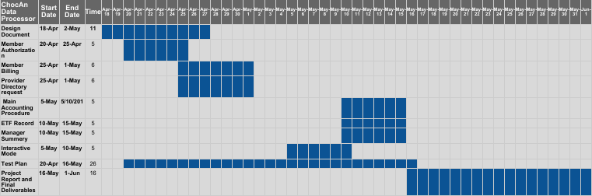
5.11 Gantt Chart of progress timeline

